STOCK MARKET CHARTING

MILESTONE 2

EMP ID: 765623

NAME: MADHUPREETHA J

GITHUB LINK: https://github.com/Madhupreethajkp/SpringJpa_Milestone2

INSERT COMPANY DETAILS

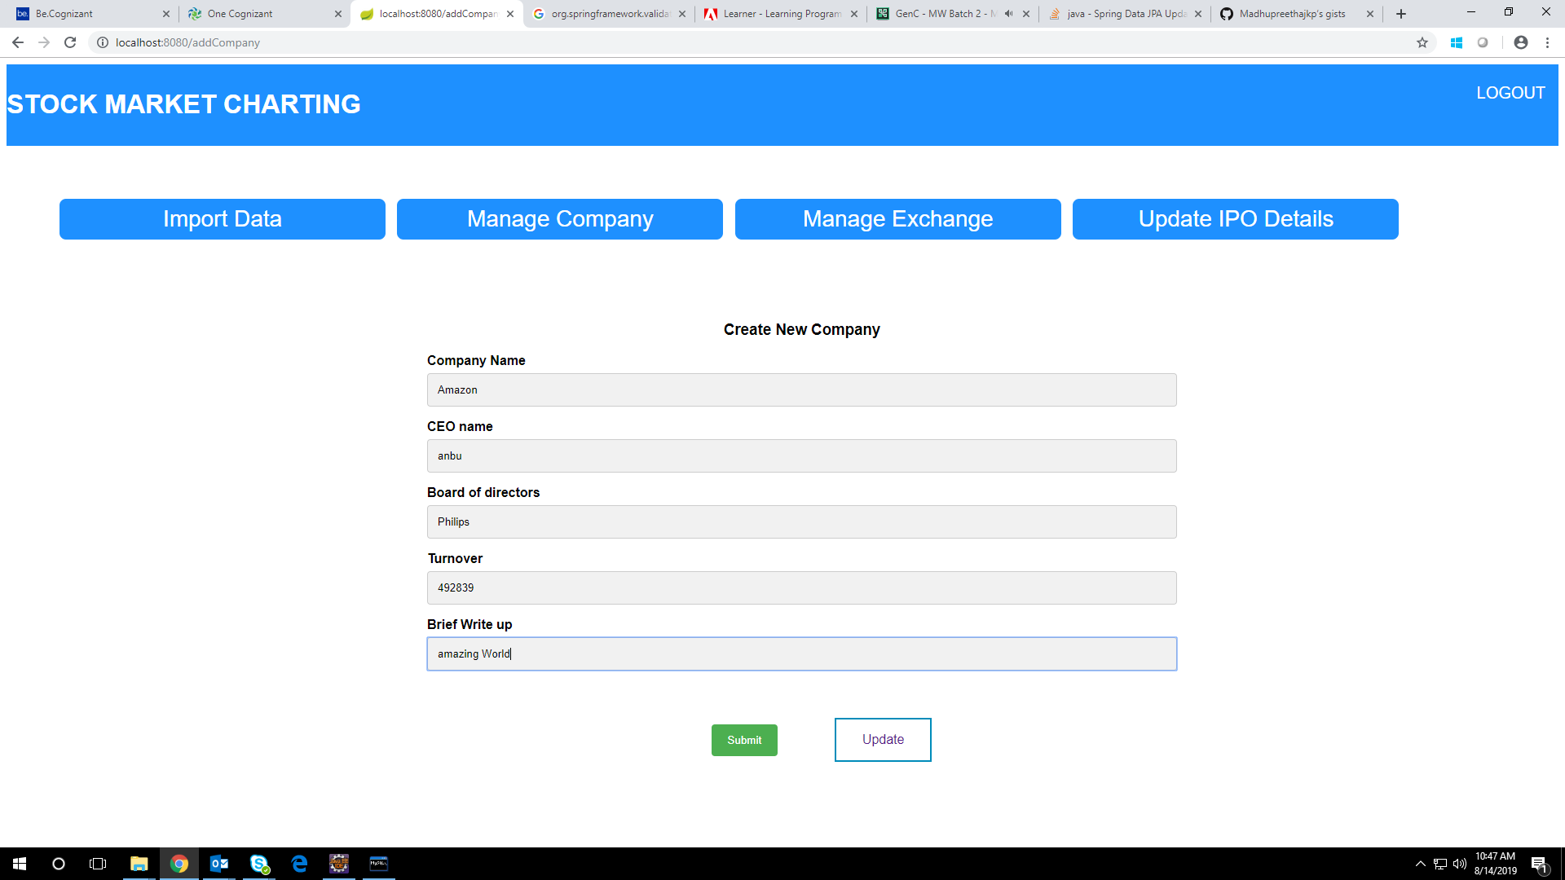

LIST COMPANY DETAILS

